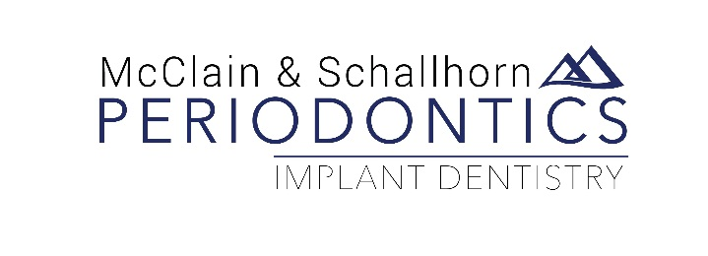

Release of Records

Date: ______________________

To: _______________________________________________________________

I ________________________________________hereby authorize you to transfer or make available to:
(Please print full name)

_____________________________________________________________________________________
_____________________________________________________________________________________
_____________________________________________________________________________________
Records, x-rays, and reports relating to my case.

____________________________________________________
Signature of Patient (or parent)

____________________________________________________
Witness

Pamela K. McClain, DDS Diplomates, American Board of Periodontology Rachel A. Schallhorn, DDS, MS
11200 E. Mississippi Avenue ● Aurora, Colorado 80012-3202 ● (303) 696-7885 ● FAX (303) 696-1958 ● www.periocolorado.com

